**Interview Questions & Class Notes**

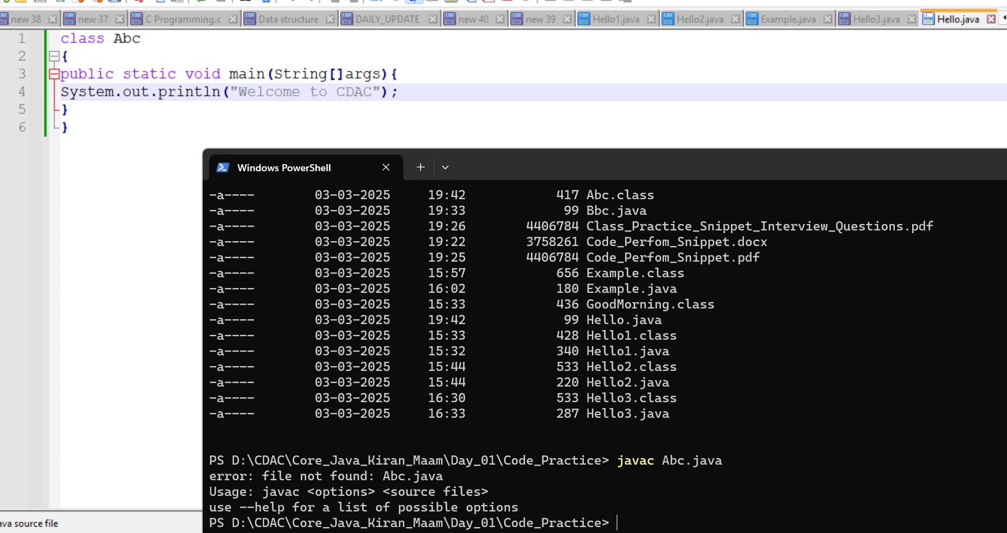

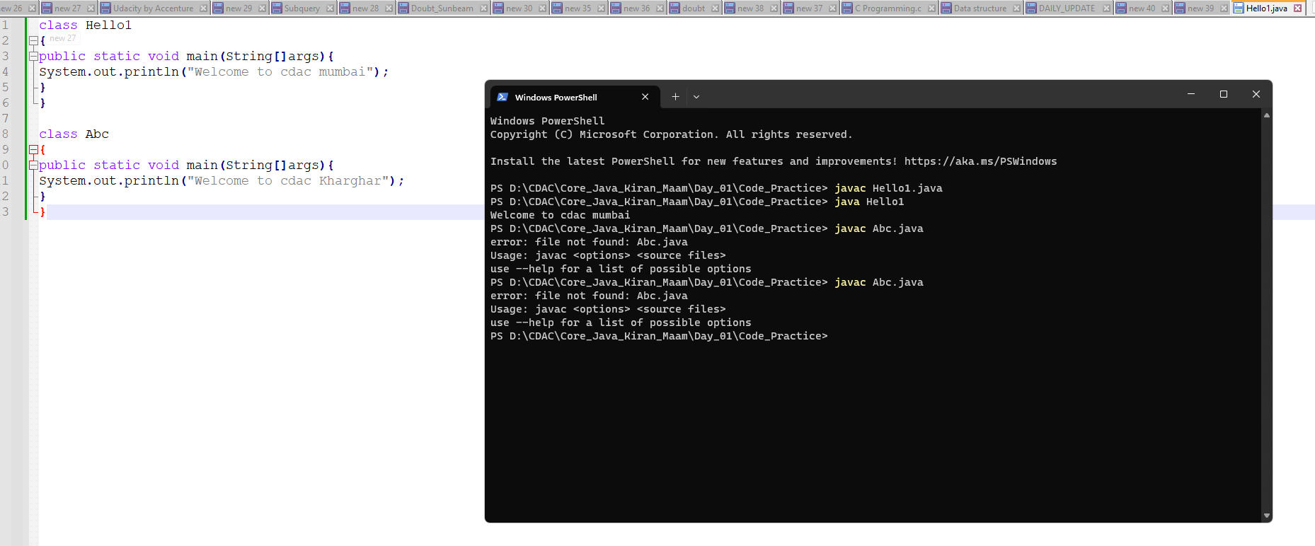

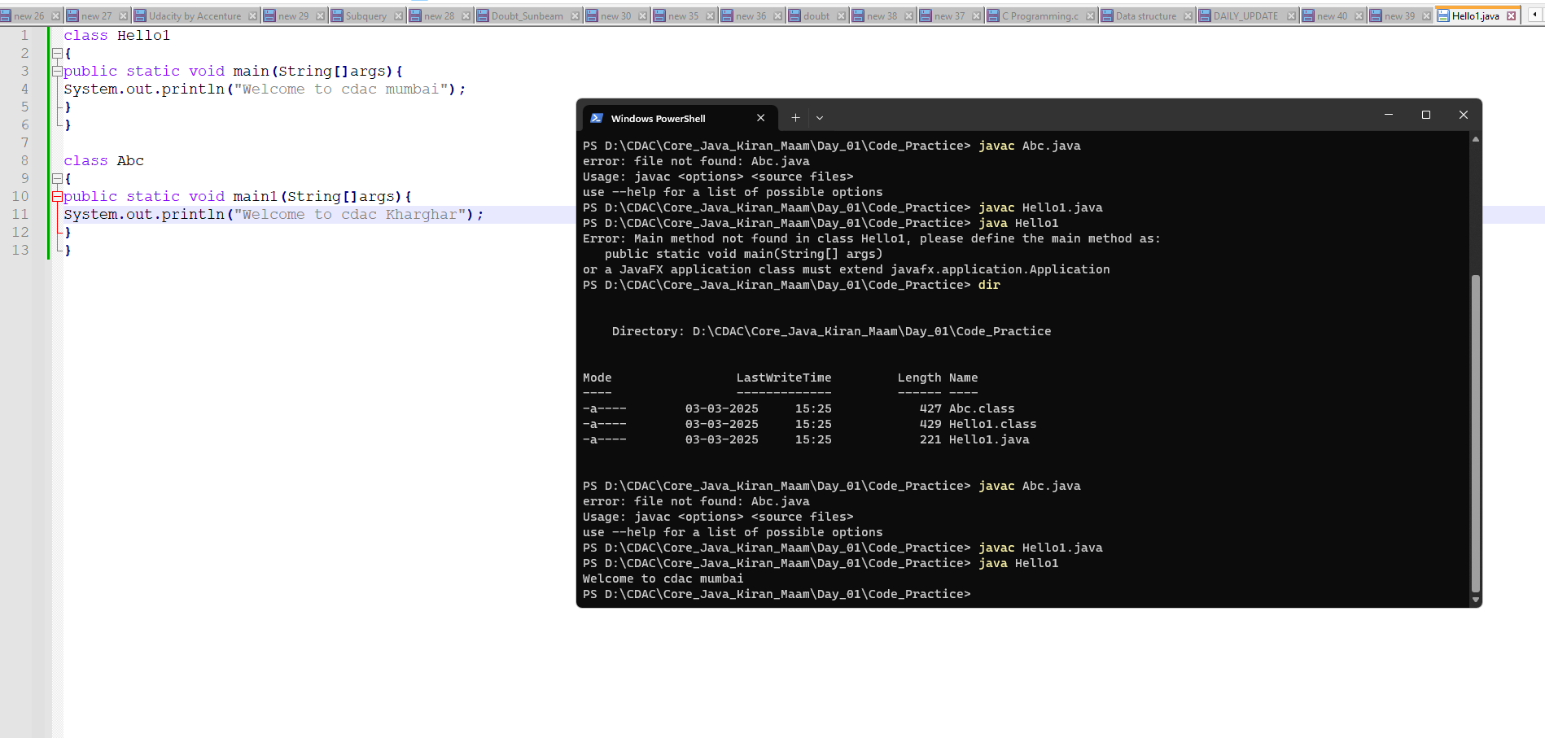

Classes kitne bhi (usji sirf class file generate hogi)ho but jis nam se file save krenge vha ka hi statement execute krega.

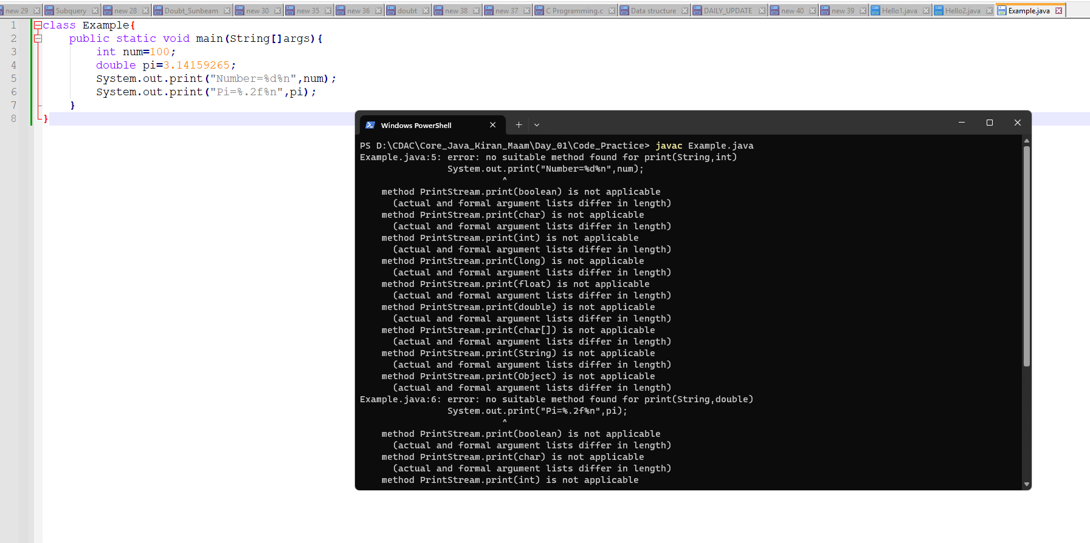

It gives error because print it is not for formatting , print use with string blank space…

**Exercise:**

**Identify Valid and Invalid main methods from the following cases: valid : yellow , invalid : red**

public static void main(String[] args)

public static void main(String  []args)  : No matter of space

public static void main(String args[])

public static void main(String... args)

static public void main(String[] args)

public static final void main(String[] args)

final public static void main(String[] args)

final strictfp public static void main(String[] args)

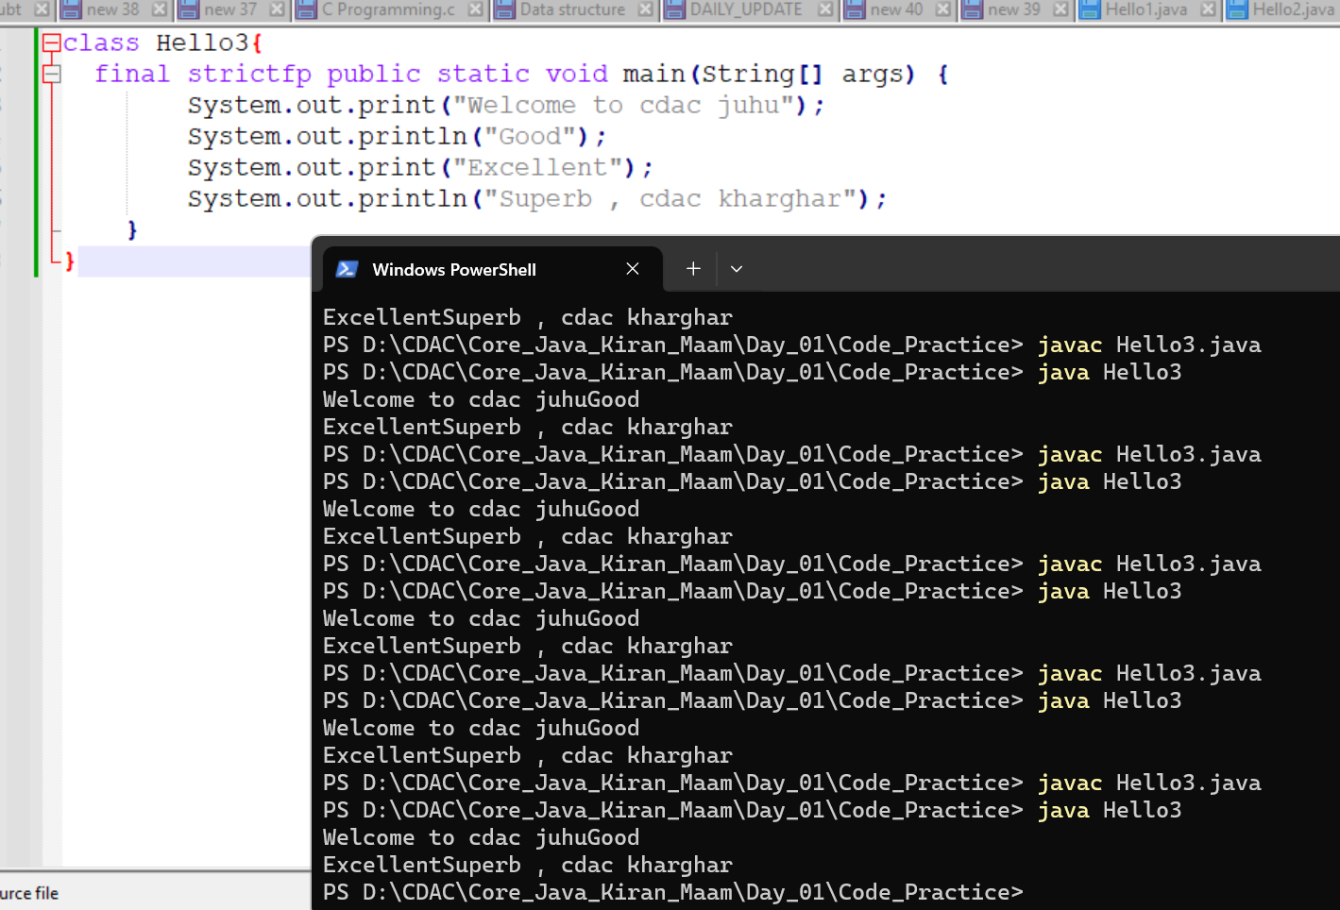

strictfp is unnecessary unless you are working with floating-point operations that need strict adherence to IEEE 754.

public void main(String[] args)   : Runtime error

static void main(String[] args)

public void static main(String[] args)

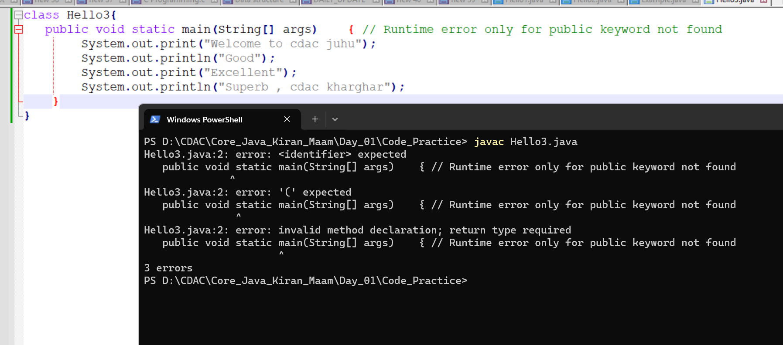

Not runtime error compile time error

abstract public static void main(String[] args)  : Compile time error

**Interview Questions:**

**1. What is Java?**

Java is a high-level, object-oriented programming language developed by **Sun Microsystems** (now owned by Oracle). It is designed to be **platform-independent**, **secure**, **robust**, and **multithreaded**, making it ideal for building various applications such as web, mobile, and enterprise applications.

**2. Explain the features of Java.**

Java offers several powerful features:

* **Platform Independence** – Java programs can run on any system with a JVM (**Write Once, Run Anywhere - WORA**).
* **Object-Oriented** – Everything in Java is based on objects and classes.
* **Robust** – Strong memory management, exception handling, and garbage collection.
* **Multi-threaded** – Supports concurrent execution of multiple tasks.
* **Secure** – Uses a security manager to define access rules for classes.
* **Automatic Garbage Collection** – JVM automatically manages memory using garbage collection.
* **Interpreted and Compiled** – Java is compiled into bytecode, which is then interpreted by the JVM.
* **High Performance** – Uses Just-In-Time (JIT) compiler to optimize execution.
* **Dynamic and Extensible** – Supports dynamic memory allocation and external libraries.

**3. What is the difference between JDK, JRE, and JVM?**

| **Component** | **Description** |
| --- | --- |
| **JDK (Java Development Kit)** | A software development kit that includes JRE + development tools like compiler (javac), debugger, and JavaDoc. |
| **JRE (Java Runtime Environment)** | Provides the necessary libraries and JVM to run Java applications but does not include development tools. |
| **JVM (Java Virtual Machine)** | An abstract machine that runs Java bytecode by converting it into machine code for execution. |

👉 **JDK = JRE + Development Tools**  
👉 **JRE = JVM + Java Libraries**

**4. Why is Java platform-independent?**

Java is platform-independent because of the **JVM (Java Virtual Machine)**. Java source code is compiled into **bytecode** (not machine-specific). This bytecode can run on any system with a compatible JVM, making Java applications portable.

**5. What is the difference between compiled and interpreted languages?**

| **Feature** | **Compiled Language** | **Interpreted Language** |
| --- | --- | --- |
| **Execution** | Converts entire code to machine code before execution. | Translates and executes line by line. |
| **Speed** | Faster since it runs machine code directly. | Slower due to real-time translation. |
| **Example Languages** | C, C++ | Python, JavaScript |
| **Error Detection** | Errors are detected at compile-time. | Errors appear at runtime. |

**Java is both compiled and interpreted:**

* The **javac** compiler converts Java code into **bytecode**.
* The **JVM** interprets bytecode into machine code during execution.

**6. What is the difference between C++ and Java?**

| **Feature** | **C++** | **Java** |
| --- | --- | --- |
| **Platform** | Platform-dependent | Platform-independent (JVM) |
| **Memory Management** | Manual (pointers) | Automatic (Garbage Collection) |
| **Multiple Inheritance** | Supported | Not supported (uses interfaces) |
| **Object-Oriented** | Partially (supports procedural programming) | Fully object-oriented |
| **Compilation & Execution** | Directly compiled to machine code | Compiled to bytecode and executed via JVM |
| **Exception Handling** | No built-in exception handling | Built-in exception handling |

**7. What are the four pillars of OOP in Java?**

1. **Encapsulation**
   * Wrapping data and methods into a single unit (class).
   * Example: Using **private variables** and providing access via **getter/setter** methods.
2. **Abstraction**
   * Hiding implementation details and exposing only essential features.
   * Example: Using **abstract classes** and **interfaces**.
3. **Inheritance**
   * Enabling one class to inherit properties and behaviors from another.
   * Example: class Child extends Parent {}
4. **Polymorphism**
   * Allowing the same method to have multiple implementations.
   * **Compile-time polymorphism (Method Overloading)**
   * **Runtime polymorphism (Method Overriding)**

**8. What is Object-Oriented Programming (OOP)?**

OOP (**Object-Oriented Programming**) is a **programming paradigm** that models real-world entities using **objects** and **classes**. It enables **modularity, reusability, scalability, and easier maintenance** of code.

**Key Concepts of OOP in Java:**

1. **Objects** – Instances of classes that represent real-world entities.
2. **Classes** – Blueprints or templates for creating objects.
3. **Methods** – Define behaviors/actions an object can perform.
4. **Attributes (Fields/Properties)** – Define the state of an object.

**Benefits of OOP:**

**Code Reusability** – Inheritance allows code reuse.  
 **Modularity** – Code is divided into objects, making it manageable.  
 **Flexibility & Scalability** – Easily extend features using polymorphism.  
 **Security** – Encapsulation hides data from unauthorized access.